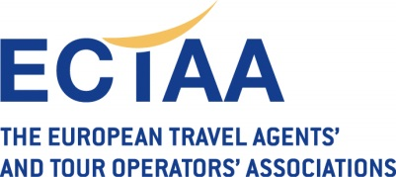  Ref.: Air Safety 22020 EU black list December | From: Christina Russe  To: Members  Delegates of the Air Matters Committee  Delegates of the Tour Operators Committee  Date: 7 December 2020

Re: Update of the EU Air Safety List

On 2 December the Commission adopted an updated EU Air Safety List. The new list has been published in the Official Journal of the EU on 7 December and will enter into force on 8 December 2020 (day after publication in the Official Journal).
For reminder, the EU Air Safety List is a list of airlines which are either considered not to be able to respect international aviation safety standards, or whose civil aviation authorities are deemed unable to provide the necessary safety oversight as foreseen by international aviation safety rules. The airlines mentioned on the EU Air Safety List are not allowed to operate to the EU, except for some of them, which can only do so under very strict conditions. The EU Air Safety List also serves as a tool to warn the travelling public when travelling in other parts of the world.
The EU Air safety list can be consulted from the following link:
https://ec.europa.eu/transport/modes/air/safety/air-ban_en
There are no changes compared to the previous EU Air Safety List published in June 2020.
The EU blacklist contains a total of 96 airlines that are banned from EU skies, notably:
- 90 airlines certified in 16 states (Afghanistan, Angola (with the exception of 2 airlines), Armenia, Congo (Brazzaville), Democratic Republic of the Congo, Djibouti, Equatorial Guinea, Eritrea, Kyrgyzstan, Liberia, Libya, Moldova (with the exception of 3 airlines), Nepal, São Tomé and Príncipe, Sierra Leone and Sudan), due to inadequate safety oversight by the aviation authorities from these states
- 6 individual airlines, based on serious safety deficiencies identified: Avior Airlines (Venezuela), Blue Wing Airlines (Suriname), Iran Aseman Airlines (Iran), Iraqi Airways (Iraq), Med-View Airlines (Nigeria) and Air Zimbabwe (Zimbabwe).
- 3 airlines are subject to operational restrictions and can only fly to the EU with specific aircraft types: Air Service Comores (the Comoros), Iran Air (Iran) and Air Koryo (North Korea).
Members are kindly reminded that travel agents and tour operators have the obligation under Regulation 2111/2005 to bring the EU Air Safety List to the attention of the passenger.
Where the passenger has a contract with a tour operator for a flight operated outside of the EU by a carrier entered onto the EU Air Safety List, the passenger is entitled to re-routing or refund.

